

Course Code : CSE 404

Course Title : Software Engineering and ISD Laboratory

Project name : Bus ticket booking management system

Experiment no: 05

Experiment name: Application of Software Development Models: Iterative and

Incremental model

**Submitted To**

**Dr. Mohammad Zahidur Rahman**

Professor

**Dr. Md. Humayun Kabir**

Professor

Department of Computer Science & Engineering Jahangirnagar University, Savar.

Group No : 02

Group members :

|  |  |  |
| --- | --- | --- |
| **Sl** | Class Roll | Name |
| 01 | 342 | Tama Shil |
| 02 | 370 | Prokash Maitra |
| 03 | 374 | Mubasher adnan jihad |
| 04 | 375 | Pritam Saha |

**Pritam Saha**

**Roll:375**

**Part: Incremental development model**

Incremental model involves developing the system in small manageable, iterations. Each iteration add new functions or feature to the system building upon the previous version. The approaches for conditions improvement, quick feedback and availability to adapt changing requirements.

**Incremental model for banking system:**

* 1st increment:

1st increment includes basic account management, basic user management, basic employee management, edit documentation.

* 2nd increment:

More details about account user employee, ATM information, documentations on production capabilities.

* 3rd increment:

Spelling and grammar check that will update the software even more.

* 4th increment:

Advance face layout capabilities. This step includes the complete software layout for the module which include:

1. Software requirement
2. Use case
3. Activity
4. UML etc

**Tama Shil**

**Id:342**

Incremental model for online Bus ticket booking management system:

**1st increment:**

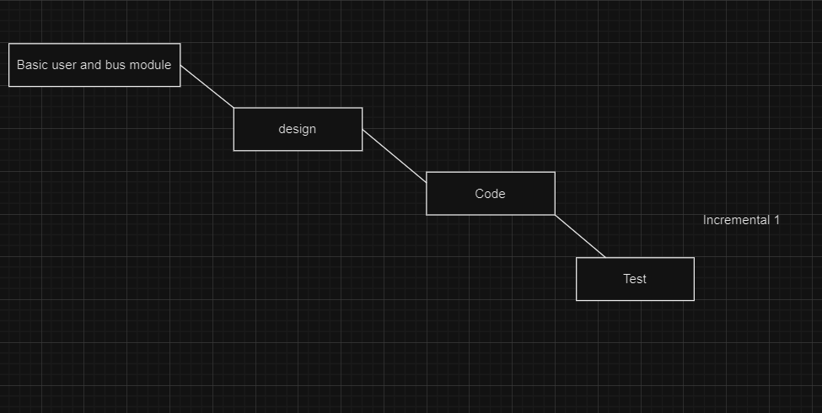

**2nd increment** 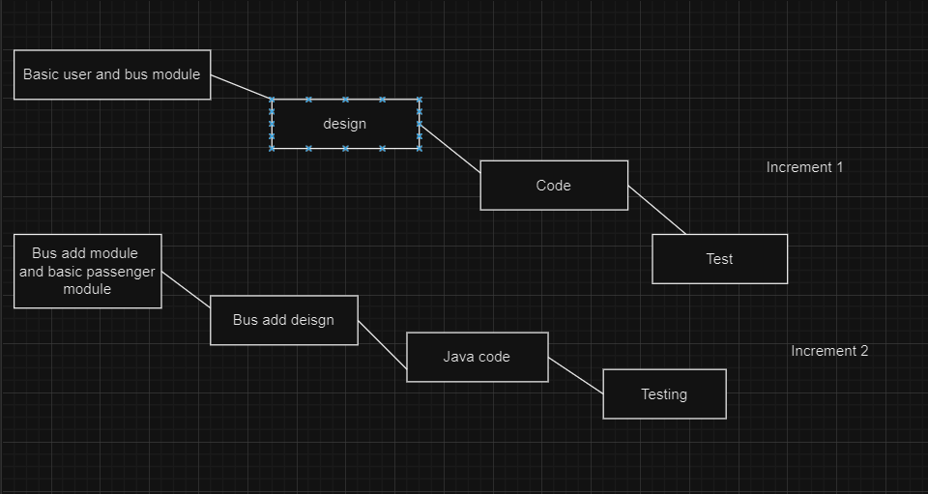

**3rd increment**

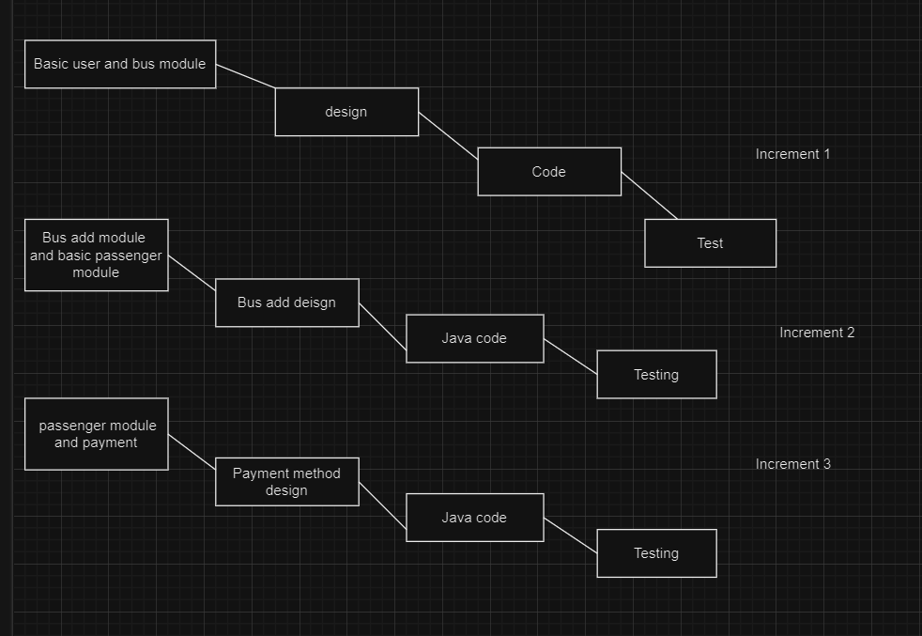

Here is step by step outline on how the incremental model can be applied on Bus ticket booking management system:

1) Requirement gathering:

Gather all initial requirements for the Bus ticket booking management system. This includes understanding needs of the bus, users and admins.

2) Design and planning:

Create high level design and architecture for the system.

3) 1st increment:

Start by basic version of system that fulfils most critical and fundamental requirements. This could include-

* user login
* user registration

4) 2nd increment:

Based on the feedback and additional requirements develop second increment. This could include-

* bus details module add
* enhancing existing functionalities
* Support user details

5) 3rd increment:

This includes-

* Spelling and grammar checking for the system
* Advance face layout capabilities.
* Ensure that each increment integrates smoothly with existing systems.

This process will continue until the final software is construed.

**Prokash Maitra**

**Roll:370**

**Part: Iterative development model**

Iterative development is a software development approach that involves breaking a project into smaller, manageable segments or iterations. Each iteration is a self-contained development cycle that includes planning, design, implementation, testing, and review

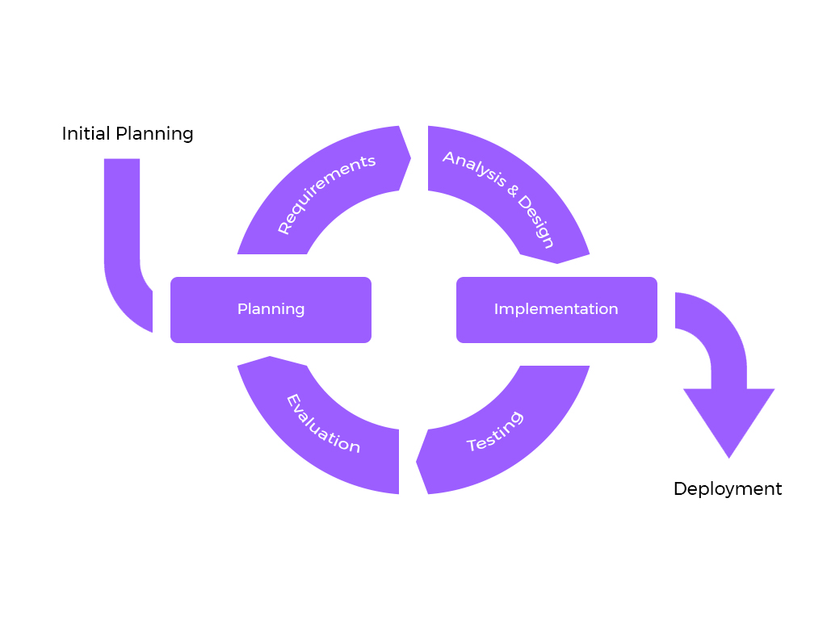

An iterative development model is a suitable approach for building an online bus ticket management system because it allows for continuous improvement and adaptation to changing requirements.

Here's a high-level overview of how you can apply an iterative development model to this project:

1. Requirement Gathering:

Gather initial requirements from stockholders, including bus operators

1. Iteration 1 - Basic Ticket Booking:

* Develop the core functionality for users to search for buses and book tickets.
* Implement a simple ticket booking process with departure/arrival selection, date, and passenger details.
* Integrate payment gateway for transactions.
* Set up a basic database for storing booking information.

1. Iteration 2 - User Management and Authentication:

* Create user registration and login systems.
* Implement user authentication and authorization.
* Develop user profiles for managing personal information and booking history.
* Enhance security features like password reset and account recovery.

1. Iteration 3 - Seat Availability and Booking Optimization:

* Integrate seat availability tracking.
* Optimize the booking process for real-time seat selection.
* Implement features like seat maps and seat preferences.
* Add waitlisting and overbooking management.

1. Iteration 4 - Payment Enhancement:

* Enhance payment processing with multiple payment methods (credit cards, digital wallets, etc.).
* Implement refund and cancellation processes.
* Integrate fraud detection and prevention mechanisms.

**Mubasher Adnan Jihad**

**Roll:374**

1. Iteration 5 - Reporting and Analytics:

* Develop reporting features for generating sales reports, booking trends, and occupancy rates.
* Implement analytics to track user behavior and preferences.
* Use data to make informed business decisions.

1. Iteration 6 - Refinement and Bug Fixing:

* Address any bugs or issues identified during previous iterations.
* Continuously improve the user interface and user experience.
* Optimize code for better performance.

1. Iteration 7 - Bus Operator Integration:

* Create interfaces for bus operators to manage their schedules and seat availability.
* Implement APIs for seamless communication with bus operators.
* Enable operators to update bus schedules and pricing in real-time.

1. Iteration 8 - Mobile App Development:

* Develop mobile apps (iOS and Android) for users to book tickets on the go.
* Ensure that the mobile app provides a similar user experience to the web platform.

1. Iteration 9 - Accessibility and Localization:

* Make the system accessible to users with disabilities (WCAG compliance).
* Implement multi-language support to cater to a wider user base.

1. Iteration 10 - Security and Scalability:

* Enhance system security to protect user data and transactions.
* Plan for scalability to handle increased traffic and demand.
* Implement load balancing, caching, and other scaling strategies.

1. Iteration 11 - Feedback and User Testing:

* Continuously gather user feedback and suggestions.
* Conduct usability testing and user acceptance testing (UAT).
* Use feedback to drive improvements in subsequent iterations.

Throughout each iteration, remember to follow Agile principles like continuous collaboration with stakeholders, flexibility in responding to changing requirements, and delivering working software at the end of each cycle. Regularly prioritize and refine your backlog of features and improvements based on feedback and evolving business needs.



Course Code : CSE 404

Course Title : Software Engineering and ISD Laboratory

Project name : Bus ticket booking management system

Experiment no: 05

Experiment name: Application of Software Development Models: Iterative and

Incremental model

**Submitted To**

**Dr. Mohammad Zahidur Rahman**

Professor

**Dr. Md. Humayun Kabir**

Professor

Department of Computer Science & Engineering Jahangirnagar University, Savar.

Group No : 02

Group members :

|  |  |  |
| --- | --- | --- |
| **Sl** | Class Roll | Name |
| 01 | 342 | Tama Shil |
| 02 | 370 | Prokash Maitra |
| 03 | 374 | Mubasher adnan jihad |
| 04 | 375 | Pritam Saha |